HOW DIFFERENT BI TOOLS WORK
Data visualization tools play a crucial role in modern analytics by transforming complex, unstructured, or large datasets into intuitive, graphical representations. This report explores five distinct data visualization platforms evaluated using a historical dataset of Global Space Missions & Rocket Launches (1957–Present).
1. Tableau
Tableau is a popular Business Intelligence (BI) and data visualization tool used to create interactive dashboards, charts, and reports from various data sources. It operates via a drag-and-drop user canvas that automatically generates background SQL queries using its proprietary VizQL engine.
Working Method
- Connect Tableau to local or cloud-hosted database schemas (such as the launches table).
- Clean and prepare data using the data schema window to categorize fields automatically into discrete tables.
- Drag and drop dimensional fields (e.g., Operator into Rows) and numeric fields (e.g., SUM(Launch Success) into Columns) to build charts dynamically.
- Apply analytical filtering elements (such as isolating specific operators like ISRO, NASA, and SpaceX) to scope operational views before publishing.
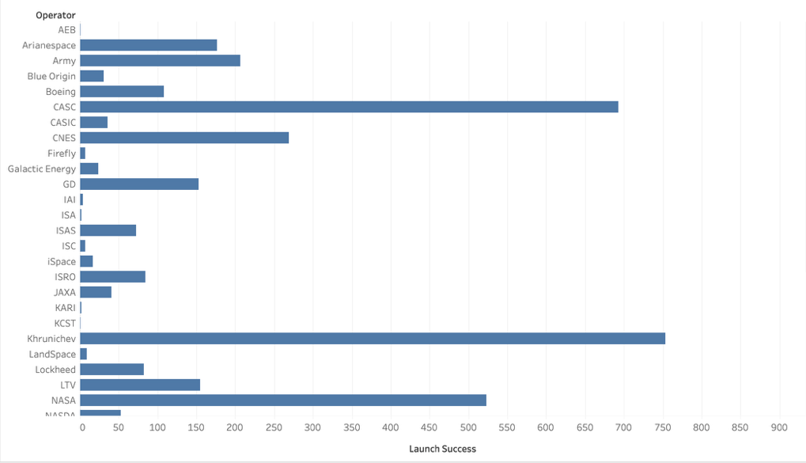
Fig 1.1: Comprehensive Operator vs. Launch Success Breakdown
•
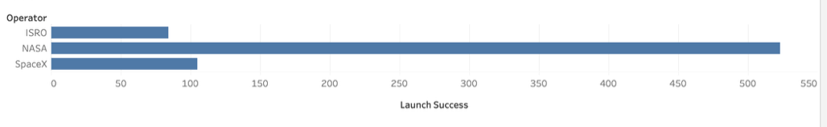
Fig 1.2: Filtered Analysis isolating Top 3 Space Operators (ISRO, NASA, SpaceX)
Advantages
- Highly intuitive and accessible drag-and-drop analytics canvas requiring no manual coding.
- Native capabilities to connect, join, and blend disparate multi-table data sources seamlessly.
- Features responsive, precise data filtering matrices to drill down into complex dataset categories.
Disadvantages
- Cost-prohibitive licensing structure for large teams or independent deployments.
- Limited native data transformation capabilities, often requiring external ETL prep software.
2. Qlik Sense
Qlik Sense is a self-service Business Intelligence tool that helps users analyze data and create interactive visualizations using its proprietary associative data engine. Rather than relying on rigid, pre-aggregated relational queries, it automatically maps links across all variables dynamically.
Working Method
- Import space exploration records into the application sheet canvas.
- Establish relational data properties and associations using the associative data model manager.
- Drag metric indicators (e.g., binding a KPI object to an expression like Count(rocket)) onto the interactive sheet.
- Use smart associative filtering to dynamically highlight subsets; clicking on a specific geographic field (e.g., China or Europe) isolates that subset's metric card instantly (e.g., displaying exactly 823 or 487 counted rockets).
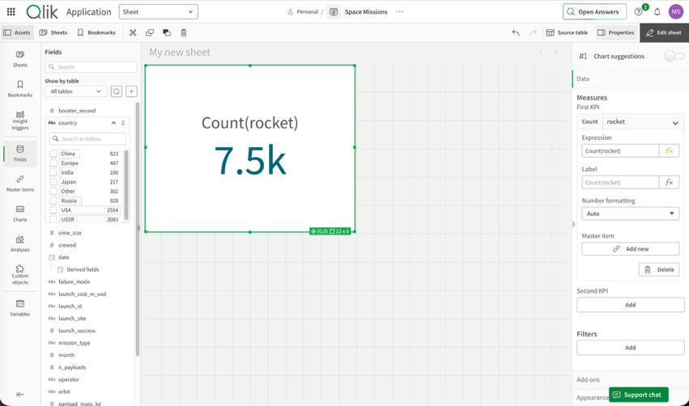
Fig 2.1: Global Space Mission Dataset - Total Accumulated Rocket Count (7.5k)

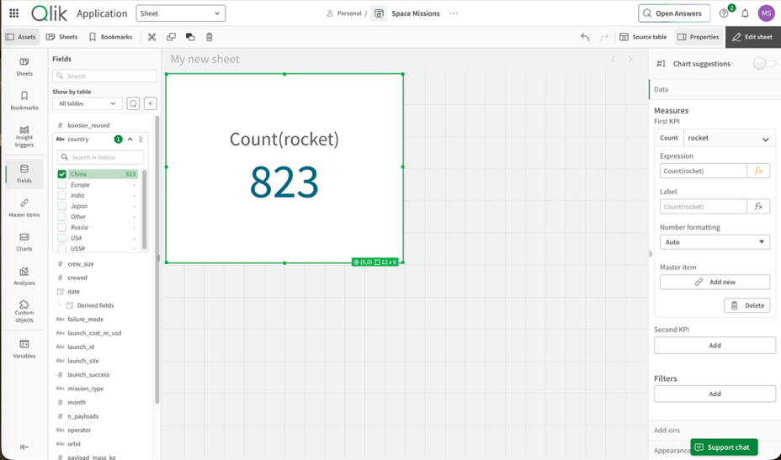
Fig 2.2: Associative Filter Applied - Isolated Chinese Rocket Count (823)
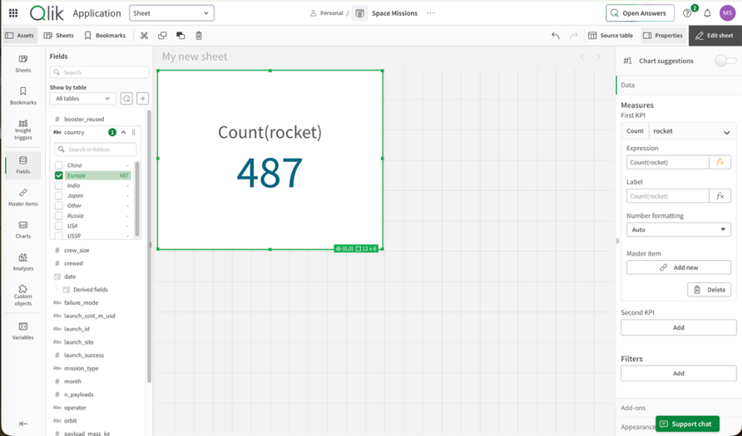
Fig 2.3: Associative Filter Applied - Isolated European Rocket Count (487)
Advantages
- The associative data engine flags un-obvious data correlations by highlighting non-selected rows in gray.
- Out-of-the-box smart search indexing across the entire database layout simultaneously.
- High processing speed for on-the-fly metric filtering and real-time aggregations.
Disadvantages
- High total cost of ownership (TCO) across complex enterprise tiers.
- Building complex metrics or data scripts requires a steep learning curve for its proprietary syntax.
3. Grafana
Grafana is an open-source observability, metric visualization, and analytical dashboarding platform heavily utilized for time-series analysis. Operating under a "single pane of glass" framework, it connects dynamically to live external storage sources via independent plugins rather than ingesting or duplicating primary datasets into its own internal data layer.
Working Method
- Launch Grafana Cloud or access a local container instance using its permanently free open-source tier.
- Install and enable independent third-party data layer plugins (such as the Infinity parser plugin) to interpret unstructured cloud streams.
- Paste raw public cloud endpoints (such as a Google Sheets CSV web URL) to stream rocket telemetry metrics directly into the editor.
- Map incoming row headers (e.g., declaring B age or B salary strings as structural numeric parameters) and drag widgets to arrange multi-metric KPI tracking cards.
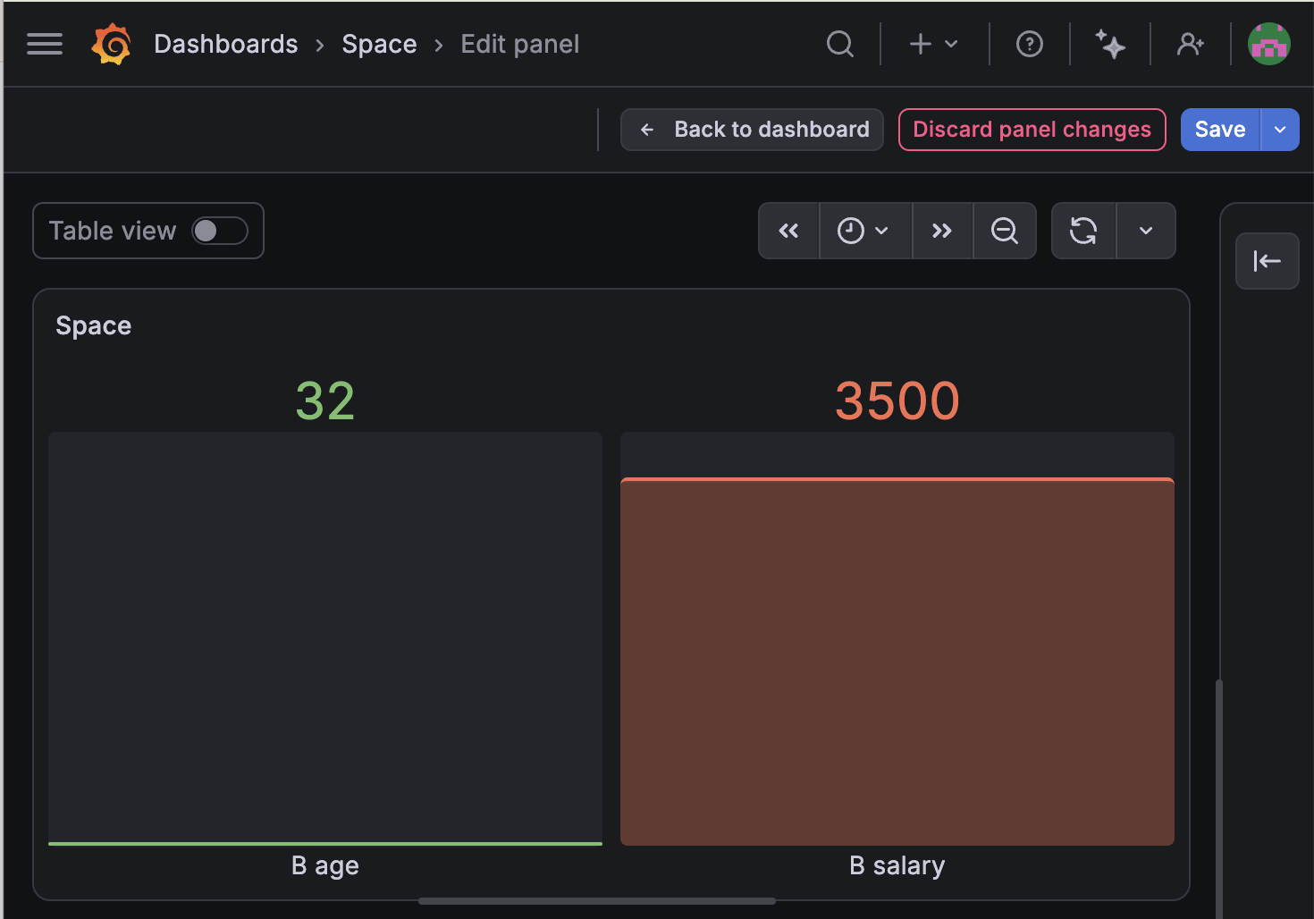
Fig 3.1: Central Infrastructure Telemetry - Live Metric Tracker Panel (B age vs. B salary thresholds)
Advantages
- Exceptional rendering speed and threshold formatting controls for time-series, log monitoring, and real-time infrastructure data.
- Permanently free cloud and open-source baseline tier with zero financial credit card verifications required.
- Combines multi-source data architectures into a single workspace without requiring database migration or ETL pipeline overhead.
Disadvantages
- Graphic interface and query structures assume an underlying familiarity with engineering logs and system metrics.
- Canvas building and component customizability are strictly grid-bound, making its visual language rigid compared to standard corporate slide presentations.
4. Plotly Dash
Plotly Dash is an open-source Python framework used to build interactive web applications and specialized analytics dashboards for data visualization without requiring JavaScript. It bridges data science backend scripts with responsive frontend web components.
Working Method
- Import core Dash layout components along with the object-oriented Plotly charting package.
- Ingest and manipulate the launches database programmatically utilizing Pandas DataFrame scripts.
- Structure the application layout using pure Python code to map UI elements like titles and graphing boards (e.g., setting a sum of launch_cost_m_usd against a country axis partitioned by rocket_era).
- Deploy the application locally or to production environments to view interactive web interfaces natively.
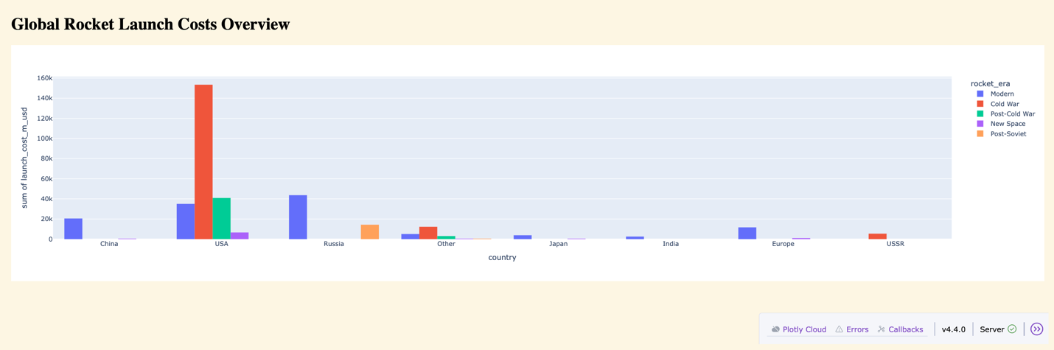
Fig 4.1: Production Layout - Global Rocket Launch Costs Partitioned by Geopolitical Space Eras
Advantages
- Gives developers complete, absolute control over layout design, callbacks, and responsive actions using only Python.
- Integrates smoothly with machine learning models and complex analytical algorithms.
- Open-source core libraries with zero external user fees.
Disadvantages
- Requires formal software engineering, package management, and programming skills.
- Lacks a rapid drag-and-drop GUI canvas, which can slow down early interface prototyping.
5. Zoho Analytics
Zoho Analytics is a cloud-based Business Intelligence (BI) and data visualization tool that enables users to connect, clean, and analyze information from multiple application streams without extensive programming experience.
Working Method
- Upload or sync the local launches CSV spreadsheet into the cloud data warehouse interface.
- Organize and format dataset columns (e.g., defining operator as textual data and launch_success as a count) within the visual modeling panel.
- Select, drag, and drop active fields directly into the specialized X-Axis and Y-Axis designer bins.
- Generate and render responsive plots automatically via the built-in graph engine.
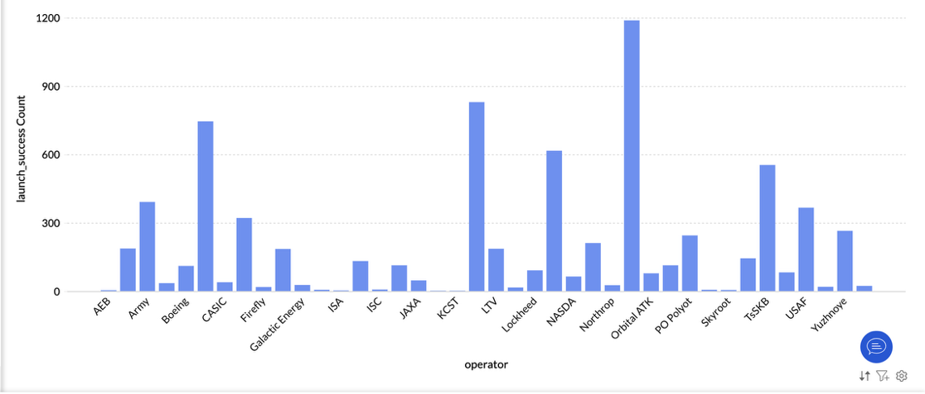
Fig 5.1: Cloud Studio Workspace - Aggregated Frequency Distribution of Operator Launch Success Counts
Advantages
- 100% cloud-native platform with quick configuration and no local setup overhead.
- Highly cost-effective subscription pricing models tailored for small and medium-sized operations.
- Built-in AI assistants to automatically parse charts and generate natural language summaries.
Disadvantages
- Restrictive interface layout adjustments compared to desktop-based alternatives.
- Advanced relational data cross-blending can become complex and requires moving up to premium packages.
Tool Comparison
Parameters | Tableau | Qlik Sense | Grafana | Plotly Dash | Zoho Analytics
Deployment Type | Desktop / Cloud hybrid | Desktop / Cloud hybrid | Cloud SaaS / Local Container | Python Script Framework / Server | Pure Web Cloud SaaS
Interface Style | Drag-and-drop Visual Canvas | Self-Service Sheet Canvas | Grid-Bound Monitoring Panel | Imperative Programmatic Code | Drag-and-drop Axis Slots
Core Architecture | Relational / VizQL compilation | Proprietary Associative Engine | Single Pane / External Plugin Ingestion | Pandas / Declarative Frontend Callbacks | Cloud Data Warehouse Hub
Coding Skill Req. | None / Low (No-Code GUI) | Low / Medium (Proprietary Scripts) | Medium (Query / Plugin mapping) | High (Python / Software Engineering) | None (No-Code Setup Wizard)
Financial Cost | Premium Enterprise Licensing | Premium Enterprise Licensing | Permanently Free Base Tier | 100% Free Open-Source Core | Low-Cost / Scalable Subscription
Best Analytical Use | Relational enterprise database exploration | Multi-variable discovery & search profiling | Time-series trends & alert monitoring | Machine learning app pipelines | Quick ad-hoc cloud spreadsheet modeling

Conclusion
The application of these data visualization tools highlights how complex, high-volume datasets can be transformed into clear charts, operational metrics, and centralized tracking boards. Utilizing distinct tools across open-source programmatic frameworks, cloud-native storage interfaces, and time-series infrastructure architectures significantly improves an analyst's ability to cross-examine telemetry logs, map performance indices, and support data-driven decision making.
Links to Blog:
- GitHub: https://github.com/mst-2005/DataVisualization
- Linkedin: https://www.linkedin.com/posts/mahita-suresh-thundiyil_blog-on-how-different-bi-tools-work-ugcPost-7483980142793367552-3o8X/?utm_source=share&utm_medium=member_desktop&rcm=ACoAAFWEjDwBMzVflgHqsDSyNR2L6ydFzgdDLfg

